West Hull Ladies
RRC

December Newsletter

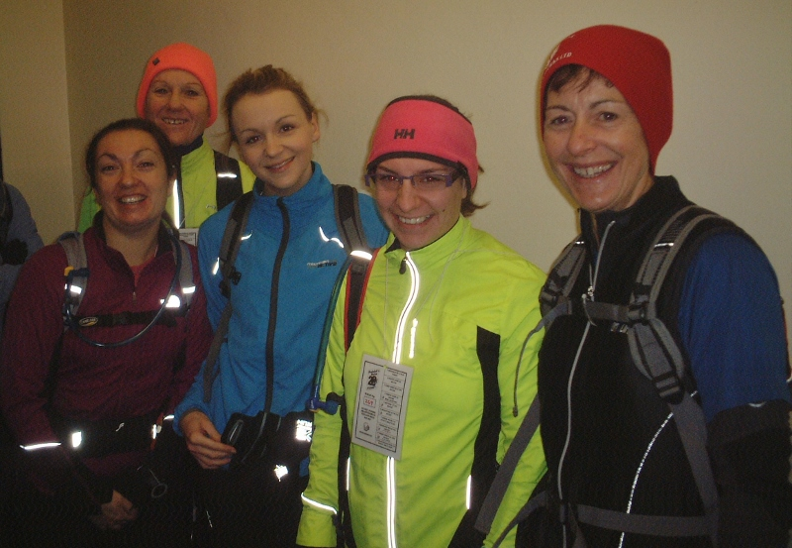

West Hull Ladies
Have a Merry Christmas and Happy New Year

WEST HULL LADIES RRC
COMMITTEE MEETING

2nd December 2013.
Due to Club being closed the meeting as such was held in the car park.
Present, Jill, Sally, Sandra, Zoe, Linda, Rachael, Verity, Ann
- Apologies from Debbie, Annette and Amanda
- Minutes of previous meeting - to be completed at next meeting
- No matters arising known.
- It was agreed that the beginners to 5K course be as the first held earlier this year and that the sum of £5 per week would be charged making a total of £30. Those completing the course would then be entitled to paid membership for the first year.
- Club Support Service .No details of this were available so to be placed on agenda for next meeting.
- Sally asked if the draw for the second place London marathon should take place, as Jo and Zoe who were eligible were present. This was agreed and Ann pulled Zoe out of the glove held by Jill. Sandra had put the names into the glove.

Deep Dale Dash 10k

Linda
I remember seeing that Sandra had put up something on Facebook about the Deep dale Dash and what a good race it was and was anyone going to enter. So I did! There was only the two of us from WHL on the day, which was very windy, very chilly too and I discovered a very hilly course! It was very well organised though, started at a school which gave us shelter before the start in their sports hall which had people selling cup cakes and hot tea/coffee on stalls! No I didn’t buy any honest.

A great and well supported fun run and all the kids won a medal and goodie bag. Then finally at 11 am it was the start of our race. A very tough start, almost straight away up hill and continuing up for a long way, you’ll be pleased to know though that I didn’t walk one step so was well chuffed although by my super duper Garmin watch when I looked at the splits I think maybe mile 5 was steeper, that mile took me the longest. So not a brilliant time as last week owing to the conditions but I did enjoy it and will I do it again, that’ll be a yes. Oh and the goodie bag was great too, plus they gave away bottles of Lucozade and the T shirt is great with long sleeves for winter, a bonus. My time on my watch was 53.38 but official finish time was 53.44.

Evil Sheriff Duathlon

Jill
I did the Evil Sheriff last year and thoroughly enjoyed it, so much so that I spent a lot of time persuading Zoe to do it with me this year. It consists of a 5k cross country run, followed by a 16k cross country bike ride, finishing with a 3k run. Last year I had been quite worried when they described the course as adrenaline filled and technical, but when I did it the going was good and I particularly enjoyed the bike ride. To be honest, the run-up to this year’s event could have been better. I missed the Scarborough 10k the week before due to a really nasty tummy bug, the after effects of which seemed to linger on in the week before the duathlon, in fact, I was in two minds whether to do it or not, but me being me decided that I would give it a go and if I felt bad after the 5k run…would pull out (ha ha…really???). So Zoe and Zoe’s boyfriend Tom and I rolled up at Sherwood pines after getting up at ‘silly o clock’ to get there for the 9am start.

In the briefing we were told that the course was quite muddy so we should wear trail trainers, and that they were trying to remove some husky racing from the course (!!??). It was quite cold, just over freezing point, so we were debating what clothes to wear, because you tend to get really hot running, and then get cold cycling, because of the wind chill. In the end we sorted ourselves out and the race started.

I was quite slow on the first run, but I was anxious about having been ill, and I think this perhaps influenced my performance and perception of the race and conditions. The run completed, I ran into transition to pick up my bike, it was at this point that things started to go a bit wrong. Firstly I tried to open my energy bar as I came in and couldn’t so instead of just calming down and opening it, I threw it on the floor and decided to rely on my energy drink, which was on the bike. I then put my helmet and gloves on and ran off with my bike. This was fine until I decided to change sides on my bike so as to be able to get on comfortably. Mistakenly, I thought that I could do this on the run like the proper triathletes do, by pushing the bike by the seat and promptly ran it into the plastic fence! Red-faced I pulled the bike out of the fence and started to run with it again. What I did then, quite frankly, beggars belief. Instead of scooting the bike and cocking my leg over, which I am perfectly capable of doing, I decided to leap onto the pedal and vault on whilst running at full pelt! The result was sadly inevitable. My foot, which was muddy, slipped off the pedal and I fell in a massive heap on top of the bike…what a numpty! I really don’t know what part of my dim intellect possessed me to do this, but fortunately I was really muddy, but actually quite okay. I later found out that my legs looked as though I had been stabbed with a chainset, but at the time I felt fine.

So off I went on the bike. Well talk about muddy! Yes it was rideable, and I would have been probably much better had I been able to overtake the riders that I kept catching up, but marathon legs and illness probably took their toll here. Being behind people who I caught up down the technical drops and on the flat, but lost out to on the climbs was really frustrating. I got well and truly spattered and pebble dashed (I’m not selling this event to you am I??), and kept nearly going up the back of the slower riders, one of whom fell off in front of me (but I can’t criticise that can I!). On the first lap, I also started to cramp my calf muscles, so daren’t push it up the climbs. I must admit, I was not really enjoying the bike at this point. There were some positives however, by easing off a bit I did get over the cramp, which I was really pleased about, and there were some really good sections of downhill which were great fun to do.

I was really relieved when I came into transition for the second time…and was much more sensible this time! I opened my energy bar for a kick off, which was useful as by this time I had been drinking energy drink adulterated with slimy mud…yuk! Although I was on even more of a go slow by this point, I was really pleased that the cramp did not come back in the second run. The only slight snag was that I nearly drowned myself with the technical water dispensers that they gave out...which I really could not get my head around (although Zoe thought they were great!). This second run seemed to go really quickly (more perception rather than reality!) and I soon found myself running up the finishing straight. Zoe, who had finished ‘hours’ previously, and Tom were cheering me on, and then they were laughing their heads off at the commentator said, ‘here comes the next competitor, No 6 Jill Jameson, a lady who is certainly looking a bit battered!’ (Hurmmmp!...although probably true!). I have to say that when I stopped at the service station on the way back home and looked in the mirror, my face was pebble-dashed with mud (Thanks for telling me Zoe and Tom!)…and I did look a bit the worse for wear lol!

Zoe said…’never again!’ and I think I might agree with her, but maybe not…who knows! Good things were a nice technical tee shirt (which actually was a women’s fit!), that I got over my cramp and the fact that I did finish the event which makes me very happy. The bad things…the mud, MUD, and MORE MUD, being ill before the event, and the cold weather! I think we ought to have a club trip next year to the evil sheriff…Have I sold it to you???

A Message From Ruth

Dear wonderful, generous West Hull Ladies

................the clue is in the use of the word ‘generous’...........

I have been fortunate(?) to get a place in The 2014 Brass Monkey Half Marathon, and, in a rush of blood to the head, decided it would be a good idea to treat it as a sponsorship opportunity to raise funds for, and awareness of, The Hull Veterans Support Centre, where my step-son is a volunteer.

Its mission statement is ‘Hull Veterans Support Centre will provide a single point of contact support service for any veteran and their family members (from any era) who are suffering from post traumatic stress disorder, ill health, homelessness, experiencing difficulties adjusting to post service civilian life, experiencing hardship due to a dramatic change in their personal circumstances or because of unemployment’.

As I haven’t got a clue how to set up a ‘just-giving’ account, I’m going to wander around with a sponsor sheet accosting kind, unsuspecting people. I won’t be upset if you say ‘no’, but if you can see your way clear to putting your name down for a quid or so I’ll be immensely grateful. The veterans have very kindly given me a form with space for 165 sponsors (not sure I know 165 people), and I’d actually like to get as near as possible to filling it, so all contributions will definitely be gratefully accepted.

Here is the web-site address if you fancy a browse.......
http://www.hullveteranssupportcentre.org.uk

Thank you very much

Rudolph Romp

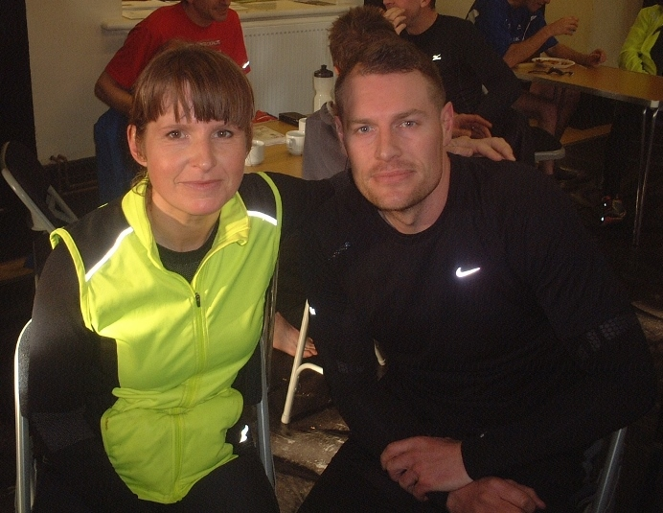
Jo
Was really looking forward to the Rudolph Romp as unlike other races I didn't feel under any pressure to get a time or run at a set pace, it was all about getting through the distance pain free and enjoying it. I set off with Dale & Shaun (Fire-fighters) and we stayed together for the first 7/8 miles and then Shaun dropped off the pace due to knee pain. Dale and I carried on and the miles just flew past, we made it very brief at the refreshment stations grabbing cake & biscuits and munching on the way. I caught up Amanda at around 15 mile mark and had quick chat about predicted finish times then carried on, I fully expected Amanda to come whiz zing past me at any point having got her second wind but amazingly it never happened. I was ecstatic to reach the village hall at 3hrs 58mins and to top it off First Lady in, way beyond my expectations, think it helped having Dale setting the pace, (he also had a very cute bum to admire ;))
It was fantastic to be able to see all the other fantastic WH ladies come charging into the village hall with massive smiles of relief, some achieving PB's and others running distances they had never dreamed of. Great achievements by great girls it's true 'West Hull Ladies Rock"!!!!!!!!!

Amanda
I had been hoping for a sub 4 hr Romp and the conditions for running were good (though warmer than I thought - I was a little over dressed). Not the best start as the loo queue held us up. Sandra and I still sauntered to the start as it never starts on time …. but it had, 3 minutes before. It was difficult to get round the walkers who covered the whole of the road and difficult to get settled down because of the "I'm late, I'm late" feeling. Seemed to be queues at every clip point today too.
However going nicely to Sancton. Jo and Dale just behind me at this point. We came together at the self clip then they were ahead. I caught them at the pig farm and told Jo we were on for 4 hours since it was 8 miles to go and we had 85 mins. Jo and Dale moved ahead now looking very strong. I was feeling tired but OK until the drag out of the valley when I started to feel sick. Arg! I hoped the walk up the steep section would sort me, unfortunately not and the last hour was pretty gruesome.
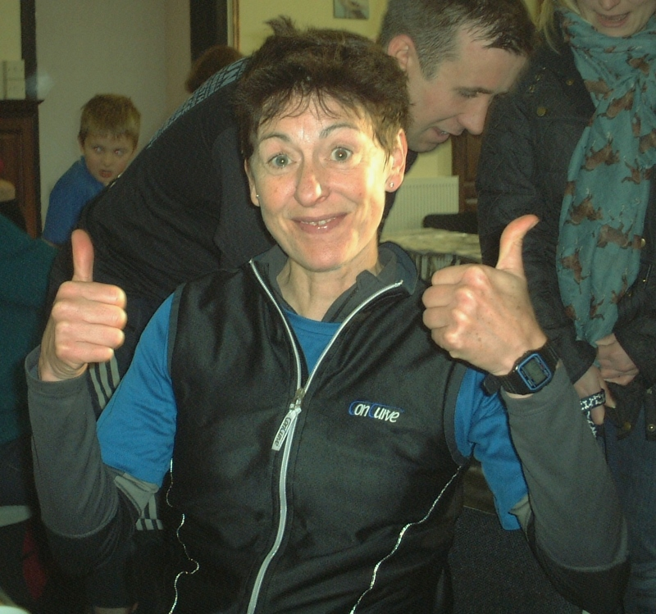
Really pleased to get back and see Jo looking as fresh as a daisy. I was told I was 2nd lady which meant Jo was 1st, go West Hull Ladies! We waited for all our amazing ladies returning in various states. I think I had a PB this year but I am wondering if I am cut out for distance running.

Laura
Verity, Becca, Zoe and I set off slightly late due to queues at the ladies for that all-important last toilet trip. As a result it took us a little while to break through the pack of walkers, but we were soon running at a good pace and chatting away, keeping our target of sub-5 hours in mind. The weather was ideal, and despite me being much hungrier than anticipated and having to eat early, we continued to run well, with just a few niggley aches and pains starting to surface. We met Jane and Lynne around mile 5/6 which was a great boost, and really impressive to see them both running so well. At 12 miles we had decided to have a proper stop, sweet tea for Becca, top up of juice for the rest of us, various pills popped and some fantastic snacks. I had started to worry the food I'd packed wasn't going to be enough, so I credit those bits of flapjack with getting me back to Brantingham!

Once we'd cracked the half way mark I felt much better, and was excited to be counting down the miles. Verity set us tough but achievable targets to get us to each next landmark, and only let us walk when we really needed to! Her knowledge of the route and encouragement were just fantastic. Along with Becca's brilliantly optimistic projections of our mileage and progress ('almost half way!' at mile 8, 'practically home!' at mile 17...) my spirits stayed high. We met Linda, Sandra and Deb at about mile 19 (I think?) which was fantastic, great to see friendly faces along the way and see everyone doing so well.
The last couple of miles were tough (why does Steep Hill have to be at mile 22?!), but adrenaline and excitement took over and I was eager to run as fast as possible. Zoe hung back with a tight calf and hip, but encouraged the three of us to carry on and try to make our target. Once we got to the road leading in to the village we pushed hard, and managed as close to a sprint as possible after 24 miles! We made it back officially with 2 minutes to spare, and unofficially 7 minutes under our 5 hour goal. It was an amazing feeling to just manage it, and wonderful to be greeted at the Village Hall by the superbly speedy Jo and Amanda. Welcoming the other West Hull Ladies back whilst getting stuck into some hot food and drinks was the perfect way to end the event. Well done to everyone, and huge thanks all round for the support and encouragement.
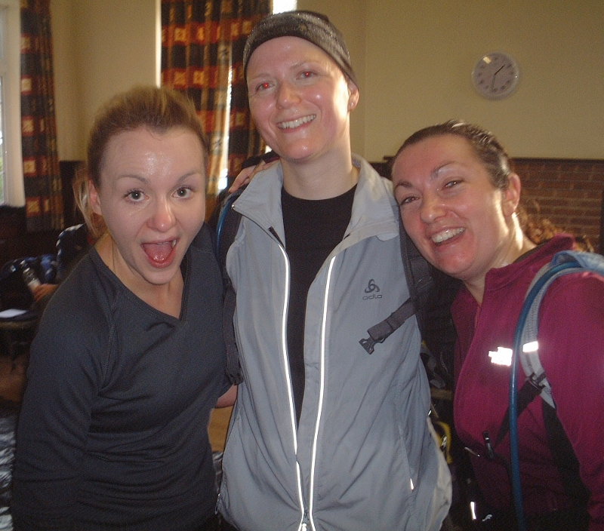
Verity
I've got just one thing to say about Rudolph's Romp 2013 - what a team! A big thank you to Zoe, Becca and Laura - the dream team! Everyone knew that my goal was to run it in under 5 hours for the first time (this was my 4th Rudolph's Romp) and everyone stepped up to the challenge! I'm chuffed to bits with my time of 4:53 - now, only one question remains - what's the goal for next year?! Well done to all the ladies who completed the race - you're amazing. Now, bring on the Golden Fleece!

Sandra
Today is the second time I have done the Romp so you would have thought I would have been better organised. I am not sure what time I got to Brantingham but after the obligatory toilet visit I started to walk with Amanda to the start. As we got there we saw some people running with a large group walking behind. Looking at our watches we realised we had missed the start by 3 mins. So off Amanda darted and I was left to run ‘alone’. I did see Lynne and Jane and it was not until we got to the pig farm some 18/19 miles in that I met Linda and Debs. We then ran/walked together to the end.
It was a lovely day with beautiful scenery and although I didn't run with a WHL for many miles there was always someone to natter with.
I did enjoy the run despite not feeling too well and my thoughts are that the Romp is all about running in beautiful scenery with good company and just having an enjoyable few hours. I certainly did this enjoying the company of Debs and Linda, (have to agree with Debs comment about us being like the Golden Girls!). Thank you ladies. It was also great at the end walking into the village hall and being greeted with cheers from the ladies that had finished before us. Look forward to the Golden Fleece but maybe just 16 miles!

Linda
The day arrived all too quickly! What was I thinking of agreeing to do this! Arrived at the village hall and found everyone, what a great bunch of ladies we have at our club. Unfortunately Jill wasn’t well enough to run the romp so I joined up with Debbie and we decided to run the romp together. The course was tough, but I knew we could complete it after all we’d done at least 17 miles of the course on our recces. At the pig farm whilst having a welcome cuppa and cake Sandra joined us and we continued the course together. Having Sandra with her wonderful clever watch that was telling us how far we had left to go, she suddenly said, ‘YAY, just the distance to West Bulls to go and maybe we can have a pint and pie when we get there’! Well the next best thing, the village hall in Brantingham with Amanda, Becca, Verity, Laura, Jo, Zoe cheering us into the warmth and a very welcome sausage casserole and hot tea. We’d done it, 5hrs 18mins for us three and feeling a little tired (knackered)! But elated too. Thank you West Hull Ladies for being who you all are.

Deb
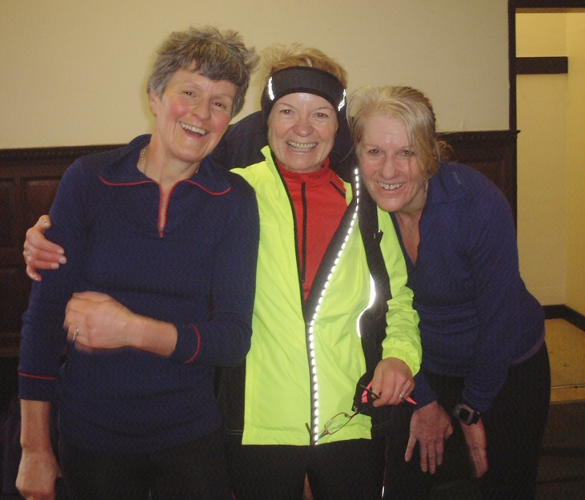
I met Linda at the start and given my penchant for running the wrong way at times I thought having not done the race before it would've good to run together. We had a very enjoyable race even though I was quite lame having 'broken down' at about 9 miles. I had been advised to maybe avoid running but thought as the RR was mainly off road I would be fine, which it was, for a bit. That said and having met Sandra at the pig farm the 3 of us chatted our way to the finish, walking and running. Hopefully next year I will be back on track. It was so nice though to have the company of Linda and Sandra and to see parts of East Yorkshire I had not seen before.

Lynne
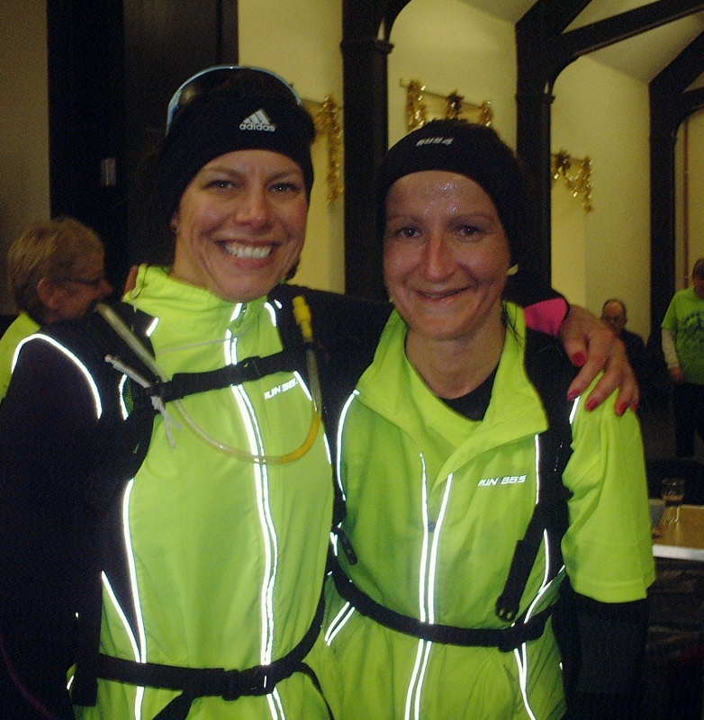
Loved it today, the weather turned out great, started off nice and steady (felt rubbish yesterday with this cold) running with Jane and we didn’t overdo the hills, in fact by the time we got to the half way point I couldn’t believe we got there so quick, it was probably all the chatting. We had a good 20 minute break before the Sancton run and stretched out our legs and popped some pills (day nurse for me and Ibuprofen for Jane). Everything was going well; we made slow and steady progress and managed to get round ok. I must say on the last two downhill runs one at about the last 6 miles and the other much nearer to the end, my knee was really starting to bother me and I couldn’t believe how happy I was to see an uphill run and as soon as we got flatter I was ready to roll (I made us run a bit faster at the end to catch some chap up who cheated and made short cuts and we passed him and blew him right out of the water ha ha). I was absolutely thrilled to see everyone still at the Hall and we arrived to a standing ovation, thanks everyone I felt really great for that. Next year a much better time!!

Jane
This event is probably the hardest thing I’ve ever done but I am now looking forward t my next challenge "the golden fleece"!
I collected my running companion Lynne up at 7.30am. Then we proceeded to Brantingham where I met with the gang and checked in. Bonus too cause we had an indoor facility to use before the start. A nice change from a hedge or field!
This course never gets any easier I thought as we traipsed up the hill. Our calves were tightening every step. The downhill parts were also tough especially on your hips. At Sancton, the half way checkpoint we had tea and jaffa cakes which were divine. Followed by various pain relief for my feet which were seen to before going on our way. Oh no! Rabbit hole alley and that dreaded long hill to come! Lynne arrived at the top first and gently encouraged me on, along the road. Next stop "High Hunslet". We knew that this was the last climb so dug our heels in and clambered on. It was very cold at top with a bitter wind. Once you get cold it’s very hard to get warm again. Anyway downhill now but by this point I was flagging but I wasn't going to give up and Lynne certainly wouldn’t give up on me.
The hardest part was from the sheep gate, probably the last 4 miles. Up the hill then down to South Cave. Steep hill felt like a mountain not a hill I literally dragged my body up the last bit. Lynne leading and me taking up the rear. The welcome we received from the ladies was overwhelming and emotional. I was in shock. Everyone has helped me get this far but i couldn’t have done it without my fab partner Lynne. We went through highs and lows but she wouldn't let me give up. Same time next year!

Injury Management & Prevention
By Sam Young, Strength Coach and Sports Massage Therapist at Strong For Life

Injury Prevention
“98% of all the dysfunction we see with typical athletes are due to:
- Overtension (missing end range of motion) and
- Moving in a bad position” – (Starrett, 2013)

“If an athlete has a tight muscle this may compress the blood vessels embedded within it and restrict the flow of nutrients and oxygen to the muscles so that they are not able to function at their best, therefore increasing chances of injury” – (Paine, 2007)

How we can improve movement, boost performance and reduce chances of injury in athletes:

- Assess movement using the Overhead squat test:
    - Heels off the ground/feet turn out = potentially tight Calf complex
    - Knees drop in/feet flatten = potentially tight Calves and Adductors, weak/inactive Abductors
    - Excessive forwards lean = potentially tight Hip flexors/Calves/ Thoracic spine
    - Hips shift to one side = potentially tight TFL on loaded leg
    - Arms fall forwards = potentially tight Latissimus Dorsi/Pectorals/ Thoracic mobility issue

- Foam roll and mobilise tight areas; warm-up thoroughly (Graham et al, 2013)
- Activate weak/inactive muscles
- Re-test movement to make sure your athletes are moving as well as they can, coaching individuals to maintain:
- A braced, neutral spine
- Stable hip and shoulder positions
- Educate athletes/players to improve lifestyle factors which, if not addressed, could increase chances of injury: sleep deprivation, dehydration, poor nutrition, prolonged sitting/standing, and stress
- Sports Massage, which involves the manipulation of soft tissue to benefit a person engaged in regular physical activity or anybody wishing to guard against or recover from a soft tissue injury (The Sports Massage Association, 2013).
Soft tissue injury management (Paine, 2007)
Acute phase (within first two days or more of the injury):
PRICE- Protect, Rest, Ice, Compression, Elevation OR:
POLICE – Protect, Optimal Loading, Ice, Compression, Elevation: Early gentle, progressive loading promotes recovery more effectively than rest (Bleakley, Glasgow and MacAuley, 2011)

Repair phase (after the first two days or more of the injury and as swelling reduces):
- Ice massage and light massage can be used to reduce swelling, encourage circulation and stimulate healing.
- On the fourth day following the injury (or immediately if following POLICE principles), promote gentle, progressive mobility and strengthening exercises in the pain-free range over the next four to five weeks:
- Mid-range isometric contractions to restore muscular strength
- Joint mobilisations to encourage the production of synovial fluid
- Static stretches to increase circulation and restore flexibility
Remodelling phase (from three weeks to up to a year of the injury)
- Deeper and firmer sports massage to stretch the newly formed collagen fibres in the direction of the muscle fibres.
- Strengthening exercises should be introduced as soon as possible to stimulate healing and muscle hypertrophy. The benefits of strength training (Bean, 2008) that are relevant to injury prevention include:
- Improved muscular balance and posture
- Reduced lower back pain (Risch, 1993)
- Stronger tendons and ligaments = increased joint stability and structural strength
- Increased bone density = reduced risk of fractures
- Reduced body fat
Return to sport
- Test the injured area gradually with movements specific to the sport
- Consult with a physiotherapist who will ensure tissue strength, flexibility and range of motion are restored to an appropriate level.
- Ensure overall fitness levels are restored in training.
Strong For Life is an innovative and empowering strength coaching brand, which gets people moving better and stronger, increasing the confidence and health of our clients.
Follow us on twitter: @StrongForLifeUK
Email: sam@strongforlife.co.uk
www.strongforlife.co.uk (coming soon)
References:
Bean, A. (2008) Strength Training (4th ed). London: A&C Black.
Bleakley, C M Glasgow, P and MacAuley, D C. (2011) PRICE needs updating, should we call the POLICE? Br J Sports Med 2012 46: 220-221 originally published online September 7, 2011doi: 10.1136/bjsports-2011-090297
Graham Z. MacDonald, et. al. (2013) An Acute Bout of Self-Myofascial Release Increases Range of Motion Without Subsequent Decrease in Muscle Activation or Force. Journal of Strength & Conditioning Research: March 2013 - Volume 27 - Issue 3 - p 812–821. doi: 10.1519/JSC.0b013e31825c2bc1
Paine, T. (2007). Sports Massage (2nd ed). London: A&C Black.

Risch, S. et al. (1993). Lumbar strengthening in low back pain patients. Spine, vol. 18, pp. 232-8.

The Sports Massage Association. (2013). Homepage, Retrieved March 30, 2013, from http://www.thesma.org/

Starrett, K. (2013). Becoming a Supple Leopard. Las Vegas: Victory Belt Publishing Inc.

10 all day breakfasts

From http://www.running4women.com/10-all-day-breakfasts

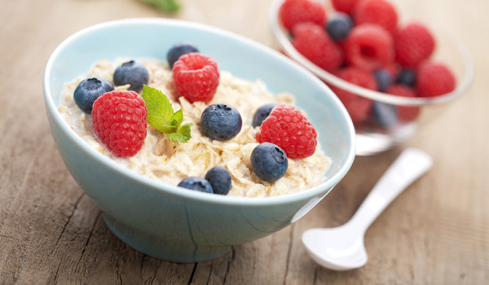

Who says porridge can only be eaten for breakfast? R4W have come up with 10 all-day breakfasts that can be consumed at any time of the day.

Porridge & Berries
Use oats and skimmed milk to make your porridge, then add any berries such as strawberries, raspberries or blueberries and honey. This is a great way to start the day as the oats have a low GI (Glycaemic Index) this tells us that oats do not raise the blood glucose level very quickly, which is good as it can help stabilise the appetite. Just go easy on the honey!

Beans On Toast
Beans (whether they are just ordinary baked beans or kidney, borlotti or black eyed beans) also have a low GI like oats. They are full of soluble fibre, which helps keep you full for longer and can therefore help you manage your weight. Serve the beans on granary toast and pass on the butter; a great, low fat breakfast or tempting lunch.

Smoked Salmon & Reduced Fat Cream Cheese Bagel
Bagels are high in starchy carbohydrates, which help kick start the body into action for the day after a fast of at least eight to ten hours. The smoked salmon provides the body with omega 3 fat which is essential for the body. Many of us eat far too much saturated fat (which is bad for us) and not enough omega 3 fat that is vital for our health.

Fruit & Yogurt
Try adding your favourite fruit to a small pot of low fat or diet yogurt for breakfast or dessert. A small pot of yogurt counts as one of your three portions per day of dairy foods, essential for the teeth and bones.

Bacon, Tomatoes, Beans, Mushrooms & Toast
For those of you who can’t resist a cooked breakfast at the weekends try this. It really is a healthy twist on a traditional fry-up and makes a great light supper too! Grill the bacon, tomatoes and large flat field mushrooms and if you pop the beans on top of the toast then you can even forgo the butter.

Crumpets & Fruit Spread
Crumpets are a starchy food (they should be the basis of every meal). The only problem with crumpets is the tendency to add lots of butter to them. Try a fruit spread, a great way to top them without adding all the calories and fat in butter.

Muesli & Milk
Swiss style muesli has milk powder added to it, which increases the calcium content of this breakfast cereal. Add calcium enriched soya milk or semi-skimmed milk and you have a bone friendly breakfast!

Fruit juice & Iron Fortified Cereal
Next time you are in the cereal aisle at the supermarket, spare a few minutes to check out the labelling on the packets. Not all cereals are equal when it comes to the vitamins and minerals that are added to them. Iron is a mineral that is added to many cereals, try sultana bran or branflakes, drink a glass of pure fruit juice such as orange or grapefruit and the vitamin C that the juice contains helps your body to absorb the iron more easily.

Smoothie
If you really can’t face breakfast try to have a smoothie instead. If you fancy trying to make one yourself (easy if you have a hand blender) then fruits such as berries, apples and bananas are great with some milk. All those anti-oxidant vitamins in the fruit help boost your immunity.

Scrambled Or Poached Egg On Granary Toast
Eggs are not bad for us! It is what you do with them… Poaching or scrambling eggs with a little milk is a good way to incorporate them into your diet. They provide valuable protein, scrambled eggs on toast is a much better choice over a fried egg sandwich and can be enjoyed any time of the day.
Racing and Running Events
Fancy something different? For worldwide marathons click here

Date/Time | Event | Fee | Entry forms | Online entry
Dec 2013
26th/10:30 | Boxing Day 10K | £4 UKA/£6 | Entry form | Online entry (+£1.40)
Jan 2014
1st/11:00 | Beverley Lions New Years Day Fun Run | £4 | Entry form | Postal entries only
1st/10:30 | Cleethorpes New Years Day 10K | £9 UKA/£11 | Entry form | Online entry (+£1.70)
19th/10:00 | Brass Monkey | Race Full | Race Full | Race Full
26th/11:00 | Ferriby 10 | £13 UKA/£15 | Online entries only | Online entry
Feb 2014
9th/11:00 | St Wilfrid's Muddy Boots | £9 UKA/£11 | Entry form | Online entry (+£1.50)
23rd/11:00 | Huddersfield 10K | £10 UKA/£12 | Entry form | Online entry (+£0.50)
23rd/11:00 | Snake Lane 10 | Race Full | Race Full | Race Full
March 2014
1st/TBC | Golden Fleece | £10 | TBC | Postal entries only
9th/10:00 | East Hull 20 | £18 UKA/£20 | Entry form | Online entry (+£1.80)
16th/TBC | Gainsborough 10K | £12 UKA/£14 | Online entries only | Online entry
April 2014
6th/11:00 | Hornsea Third | £11 UKA/£13 | Entry form | Online entry
6th/09:00 | Sheffield Half Marathon | £24 UKA/£26 | Entry form | Online entry (+£1)
6th/09:00 | Greater Manchester Marathon | £47.95 UKA/£49.95 | Online entries only | Online entry
6th/09:30 | Blackpool Marathon | £30 UKA/£32 | Online entries only | Online entry
6th/09:30 | Blackpool Half Marathon | £20 UKA/£22 | Online entries only | Online entry
13th/10:00 | London Marathon | Race Full | Race Full | Race Full
18th/10:30 | Bridlington Easter 5 Mile Dash | £13 UKA/£15 | Entry form | Online entry
May 2014
4th/09:00 | North Lincolnshire Half Marathon | £24.50 UKA/£26.50 | Online entries only | Online entry

Keep checking the website for new races and updates: www.westhullladies.org.uk/races.htm Zoe, Racing Officer

NOTE: Club Vests must be worn at any races you enter
under the West Hull Ladies running club name.


Clubwear
PRICES:
Vest | £16.00 | All items are ordered on request and must be paid for at time of ordering. To place an order please print the kit order form and hand completed forms to Maria.
T- shirt | £16.50
Hoodie | £14.00
Jacket | £32
Beanie Hat | £6.50



New Club Jacket available in three sizes: small, extra small, and junior (large fitting). If you would like to purchase one please send a cheque for £32 to Debbie Watson, Treasurer, and state on the back of your cheque your name and that the cheque is for a jacket.

Jill

West Hull Ladies Road Running Club
Kit Order Form

FORENAME ___________________________________

SURNAME ___________________________________

ORDER - tick what you require, with size Price

- VEST SIZE _____________ £16.00
- T SHIRT SIZE _____________ £16.50
- JACKET SIZE _____________ £32
- HOODIE SIZE _____________ £14
- BEANIE HAT £6.50

DATE Ordered _______________

AMOUNT PAID _______________

Please make Cheque payable to ‘West Hull Ladies’
Write your name and order on the back.

Sign on receipt of goods _________________________________

DATE _______________

Please print this form, complete and hand to me with your cheque/cash.
Thanks.
Maria
Kit Officer

